# Q4.

Code:

#include <stdio.h>

int main() {

int numElements = 15;

int numArray[numElements];

int i = 0;

while (i < numElements) {

int element;

printf("Enter element %d: ", i + 1);

scanf("%d", &element);

numArray[i] = element;

i++;

}

int sum = 0;

for (int j = 0; j < numElements; j++) {

sum += numArray[j];

}

printf("The sum is %d", sum);

return 0;

}

Screenshots: 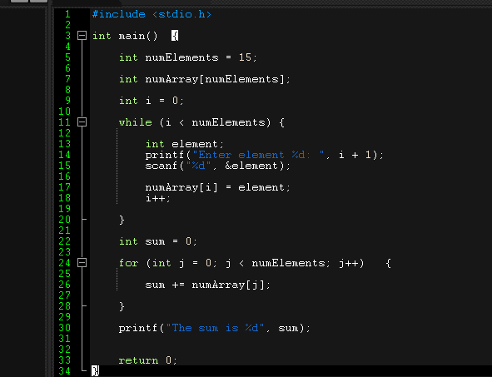

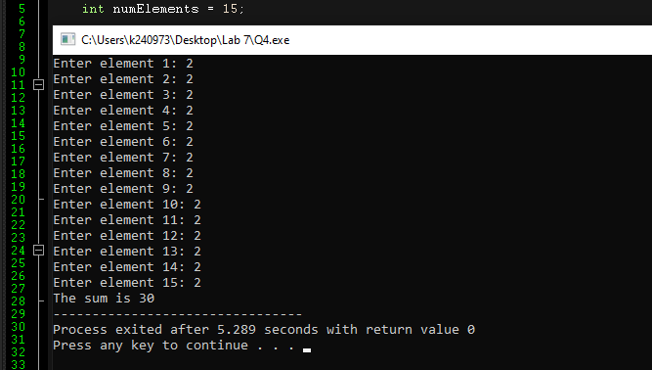

# Q5.

Code:

#include <stdio.h>

int main() {

int numElements = 20;

int numArray[numElements];

int i = 0;

while (i < numElements) {

int element;

printf("Enter element %d: ", i + 1);

scanf("%d", &element);

numArray[i] = element;

i++;

}

for (int j = numElements - 1; j > 0; j--) {

printf("%d ", numArray[j]);

}

return 0;

}

Screenshot:

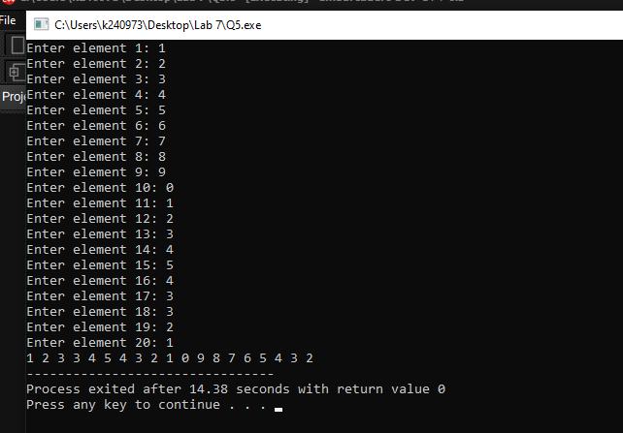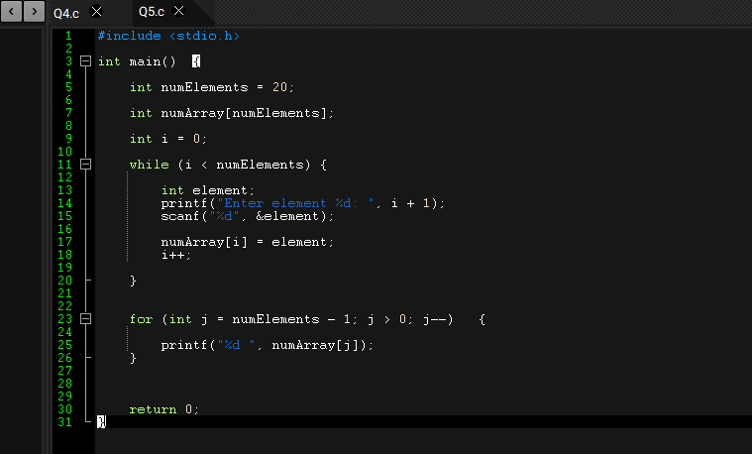

# Q6.

Code:

#include <stdio.h>

int main() {

int numElements = 30;

int numArray[numElements];

int i = 0;

while (i < numElements) {

int element;

printf("Enter element %d: ", i + 1);

scanf("%d", &element);

numArray[i] = element;

i++;

}

int minimum = numArray[0];

int maximum = numArray[0];

for (int j = 1; j < numElements; j++) {

int current = numArray[j];

if (current < minimum) {

minimum = current;

}

if (current > maximum) {

maximum = current;

}

}

printf("Maximum: %d, Minimum: %d", maximum, minimum);

return 0;

}

Screenshots: 